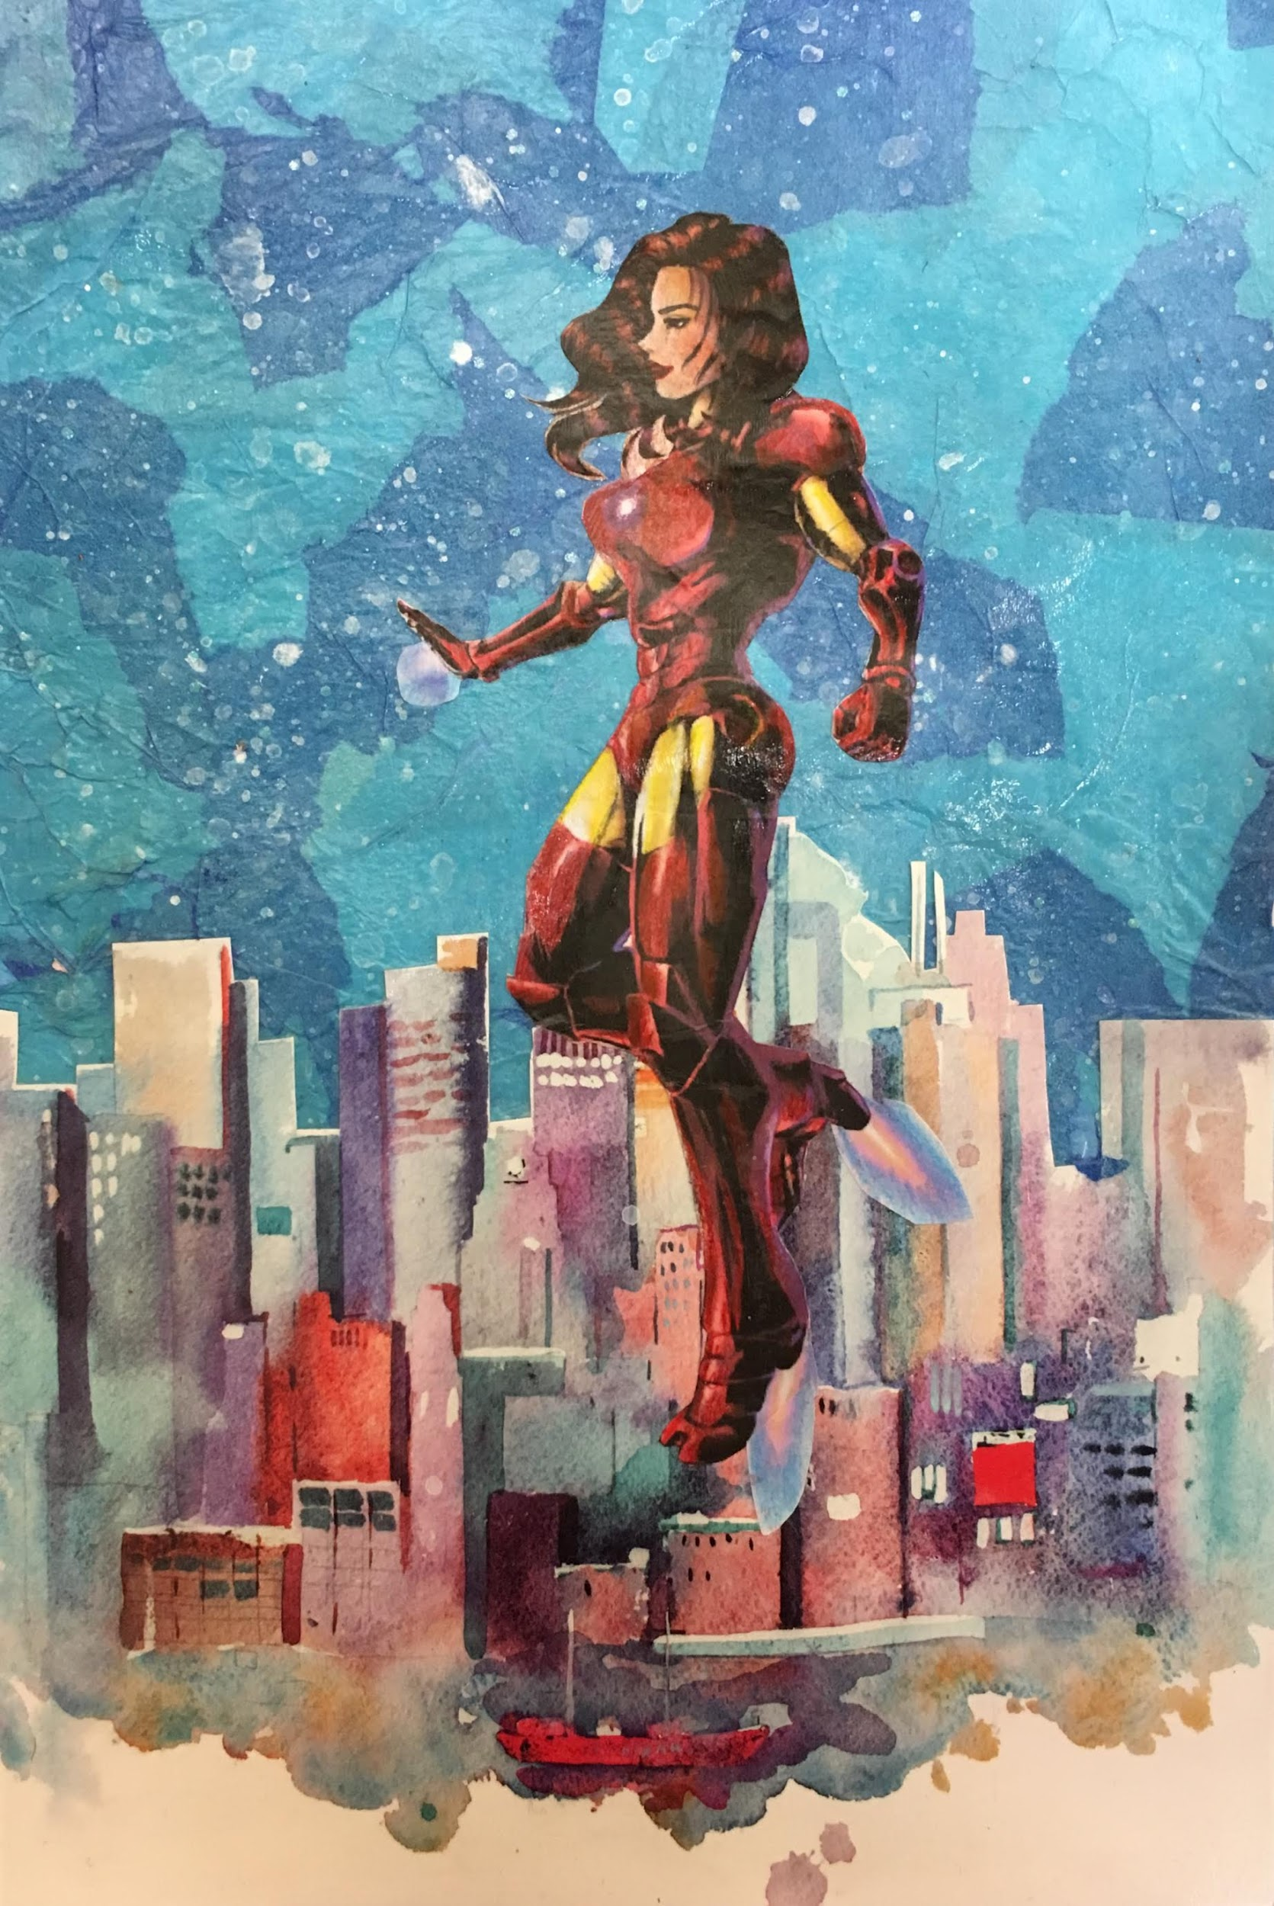

Art Supplement Explanation:

Most people grew up watching Disney Channel or Nickelodeon. My childhood, however, consisted of sci-fi reruns and superhero movies, so it’s not a big surprise that I’ve been cultivating a Marvel obsession for most of my life. From the young age of seven, I’ve watched Iron Man innovate the technology of the future, lead the Avengers, and ultimately save millions of lives. I aspired to be just like him: to push past the words of others and prove that I’m strong and intelligent, to prove that I’m undeniably a hero.

But as I grew up, I noticed the lack of female superheroes who were scientists, engineers, and mathematicians in the Marvel Cinematic Universe as well as the lack of Asian representation. Now, this got me thinking.

So yes, I still aspired to be Iron Man, a leader in innovation with a heart of gold, but I could be better. I could do everything he does but while wearing heels. My motivation and passion will push me to be the Tony Stark of my generation, inspiring many women to do the same. I desire to not only incorporate female and Asian representation into STEM fields, by not only encouraging girls to pursue science in our local middle school but by being the first female captain of the Chelmsford High School robotics team.

This is why I drew myself in the Iron Man suit, watching over my hometown, Chelmsford, Massachusetts, for any crime in need of fighting. My culture and gender don’t hold me back. Instead, it pushes me to be better and more expressive. My drawing embodies who I am: strong, intelligent, charismatic, confident, empowered, unique, and inspiring. More importantly, I am a woman, I am Asian, and I am an engineer. I am my own Iron Man.